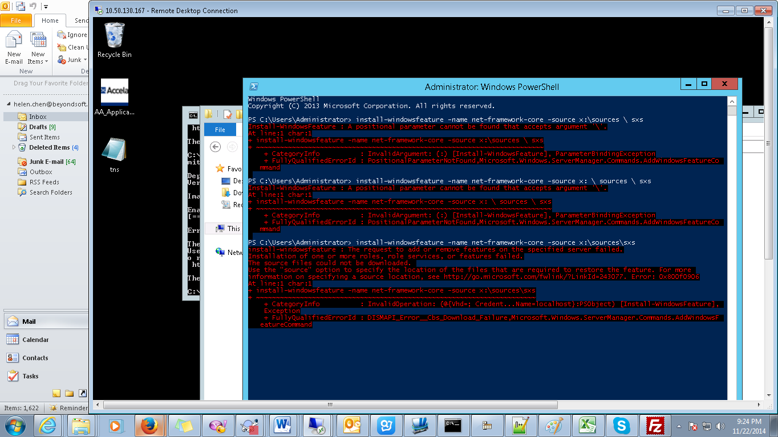

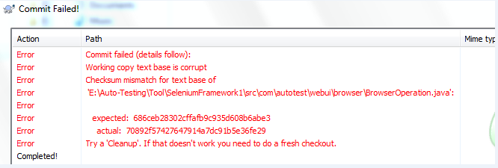

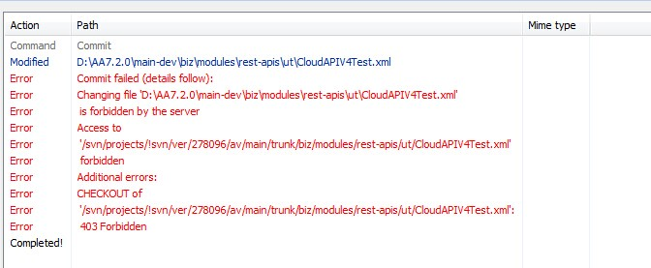

被锁了而已，第二天要重新解锁（重新加载）

a custom hook script钩子脚本

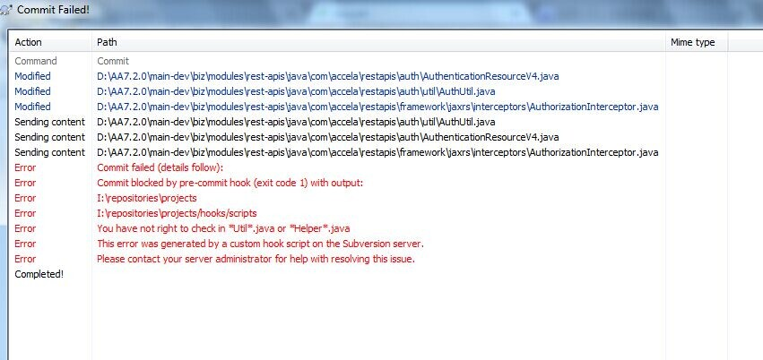

解决如下：

#only AAC member could check in "*Util*.java" and "*Helper*.java".

CkUtilFile =ACHIEVO\bruin.li,ACHIEVO\zeal.liu,ACHIEVO\afra.liu,ACHIEVO\winter.jiang,ACHIEVO\edwin.lin,ACHIEVO\saul.fang,ACHIEVO\hendry.feng,ACHIEVO\winter.jiang,ACHIEVO\hardy.xu,hardy.Xu,ACHIEVO\michael.mao,ACHIEVO\donny.chen,ACHIEVO\ken.wen,ACHIEVO\hans.shi,ACHIEVO\victor.tan,ACHIEVO\ray.zhang,ACHIEVO\ray.xie,ACHIEVO\ashley.zou,ACHIEVO\evan.cai,ACHIEVO\dylan.liang,ACHIEVO\richar.li,ACHIEVO\saul.fang,ACHIEVO\jovy.wang,ACHIEVO\bruce.deng,ACHIEVO\kay.li,ACHIEVO\john.huang,ACHIEVO\rain.wang,ACHIEVO\leon.luo

Magus Zhang: 在代码库\hooks\scripts\commonconfig.porperties里头

Magus Zhang: 他真需要就把他帐号加进去，然后他就可以提交了

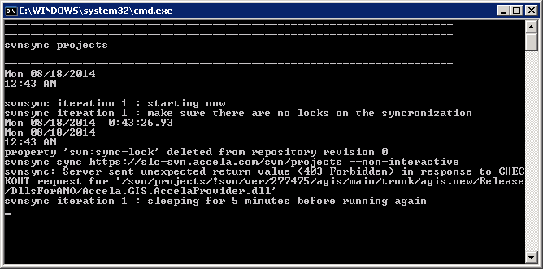

---------------------------------------------------------------------

---------------------------------------------------------------------

svnsync projects

---------------------------------------------------------------------

---------------------------------------------------------------------

Mon 08/18/2014

12:43 AM

---------------------------------------------------------------------

svnsync iteration 1 : starting now

svnsync iteration 1 : make sure there are no locks on the syncronization

Mon 08/18/2014 0:43:26.93

Mon 08/18/2014

12:43 AM

property 'svn:sync-lock' deleted from repository revision 0

svnsync sync https://slc-svn.accela.com/svn/projects --non-interactive

svnsync: Server sent unexpected return value (403 Forbidden) in response to CHEC

KOUT request for '/svn/projects/!svn/ver/277475/agis/main/trunk/agis.new/Release

/DllsForAMO/Accela.GIS.AccelaProvider.dll'

svnsync iteration 1 : sleeping for 5 minutes before running again

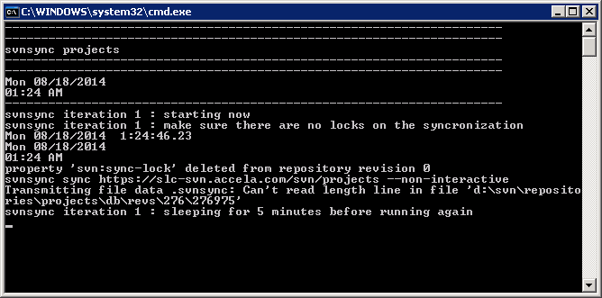

Transmitting file data .svnsyc:Can't read length line in file 'd:\svn\repositories\projects\db\revs\276\276975

property 'svn:sync-lock' deleted from repository revision 0

svnsync sync https://slc-svn.accela.com/svn/projects --non-interactive

svnsync: Destination HEAD (277402) is not the last merged revision (277401); have you committed to the destination without using svnsync?

svnsync iteration 2 : sleeping for 5 minutes before running again

svnsync iteration 3 : starting now

svnsync iteration 3 : make sure there are no locks on the syncronization

Thu 08/14/2014 17:30:00.06

Thu 08/14/2014

05:40 PM

property 'svn:sync-lock' deleted from repository revision 0

svnsync sync https://slc-svn.accela.com/svn/projects --non-interactive

svnsync: Destination HEAD (277402) is not the last merged revision (277401); have you committed to the destination without using svnsync?

svnsync iteration 3 : sleeping for 5 minutes before running again

svnsync iteration 4 : starting now

svnsync iteration 4 : make sure there are no locks on the syncronization

Thu 08/14/2014 17:30:00.06

Thu 08/14/2014

05:45 PM

property 'svn:sync-lock' deleted from repository revision 0

svnsync sync https://slc-svn.accela.com/svn/projects --non-interactive

Transmitting file data .svnsync: Can't read length line in file 'd:\svn\repositories\projects\db\revs\276\276975'

svnsync iteration 14 : sleeping for 5 minutes before running again

以上的问题都是源于之前的同步问题，解决方法如下：

<http://www.myexception.cn/cvs-svn/1076911.html>。

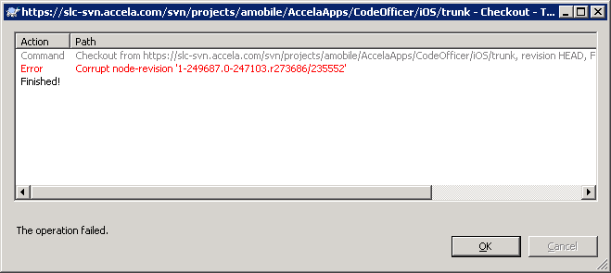

其实步骤只有：

svn proplist --revprop -r 0

svn propset --revprop -r0 svn:sync-last-merged-rev 277484 <https://slc-svn.accela.com/svn/projects>

svn proplist --revprop -r 0 <https://slc-svn.accela.com/svn/projects>

<http://gregoire.org/2008/09/03/fun-with-svnsync-and-googlecode/>

svn pdel --revprop -r 0 svn:sync-currently-copying <https://slc-svn.accela.com/svn/projects>

svnsync sync <https://slc-svn.accela.com/svn/projects>

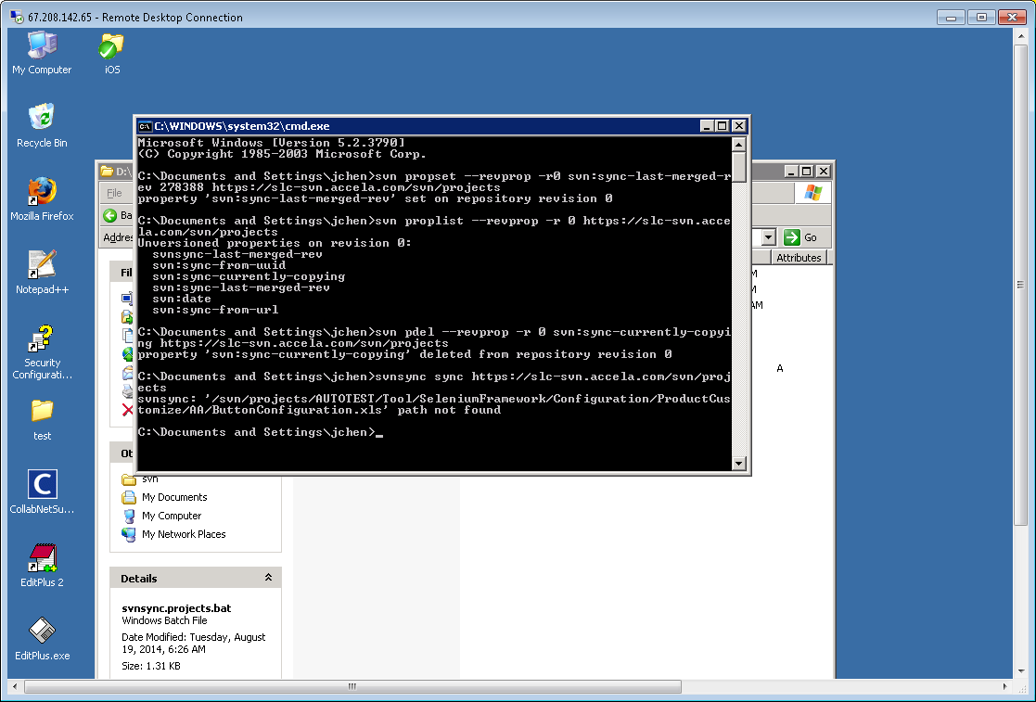

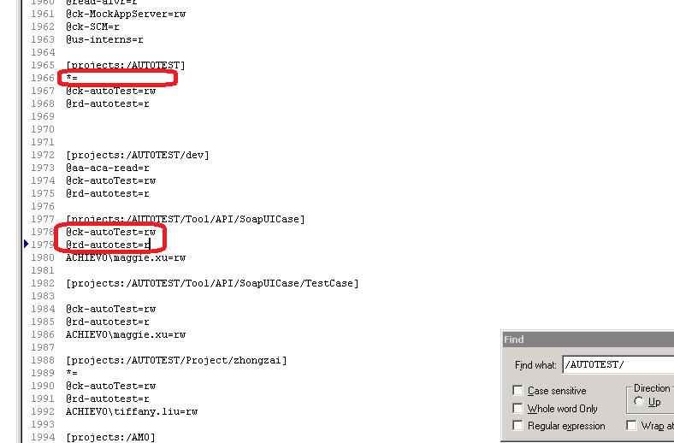

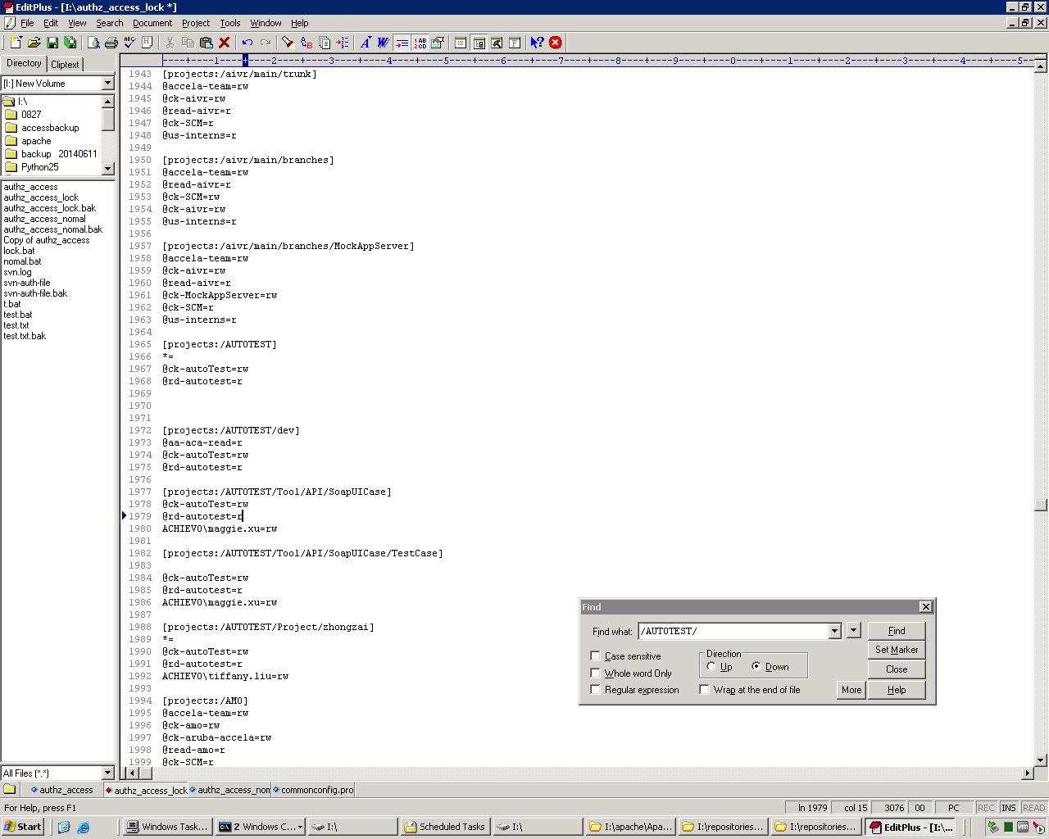

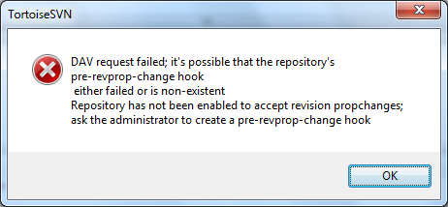

蓝色十字符合：

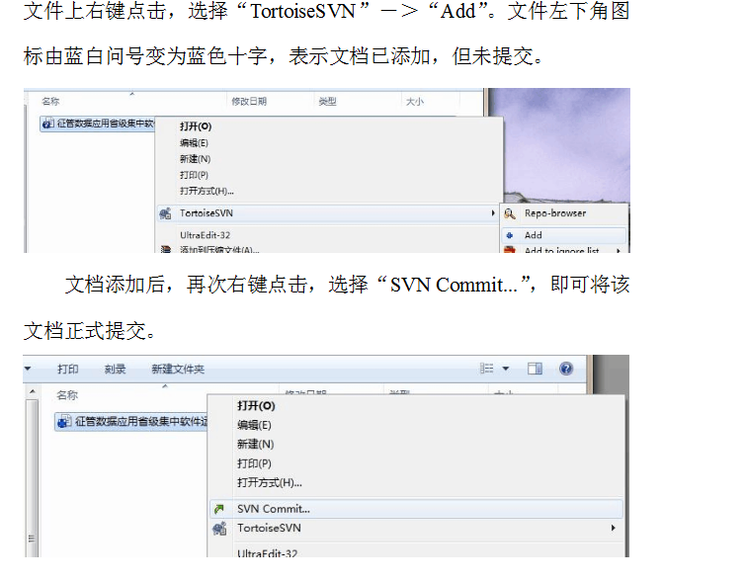

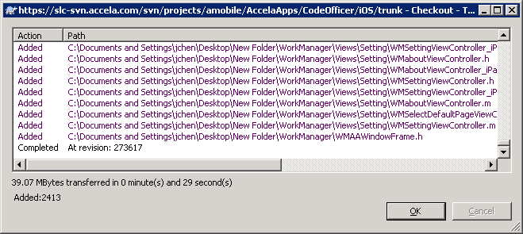

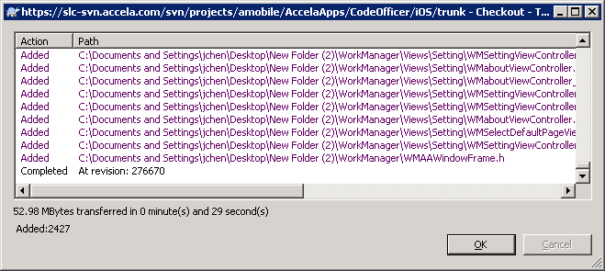

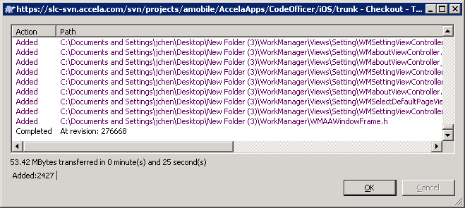

导arw 的user db出错

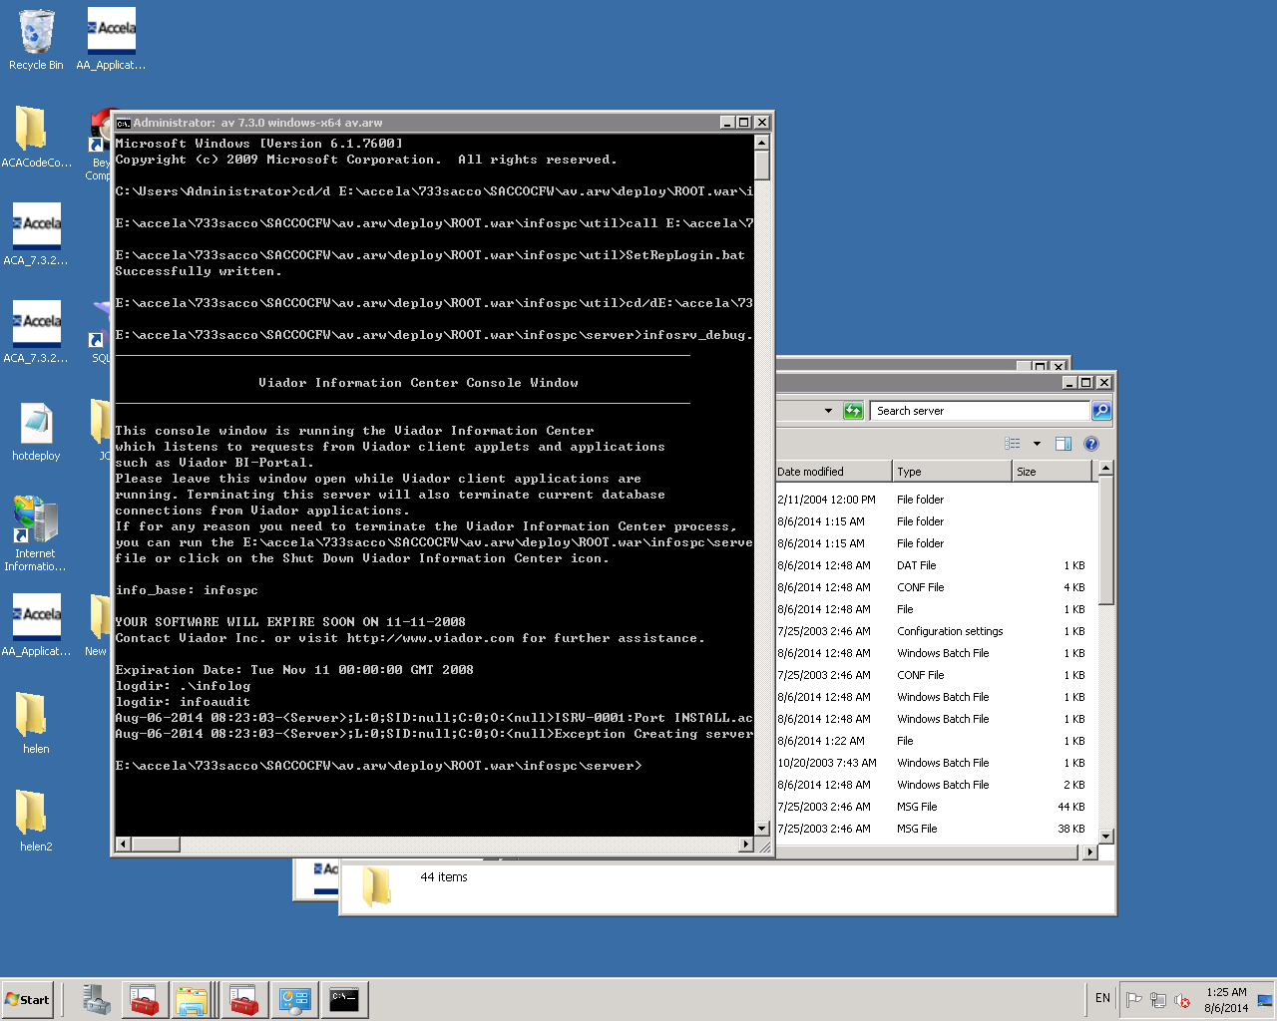

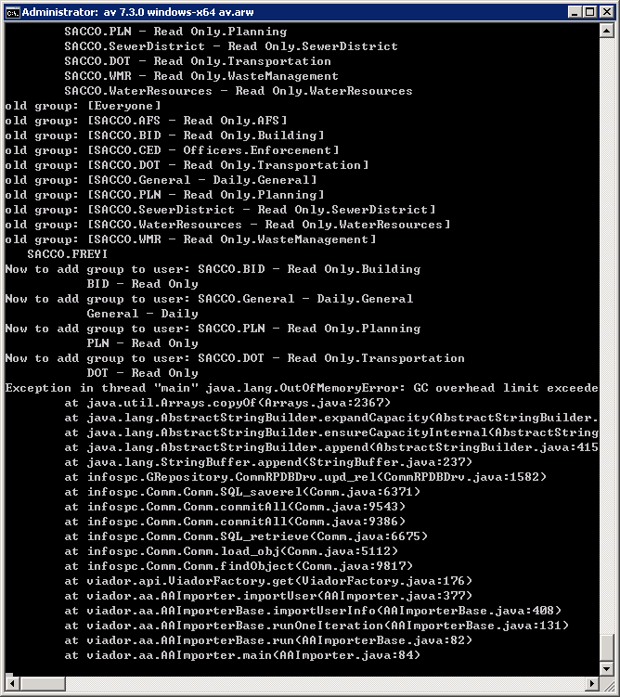

内存溢出，应该去改大点内存。

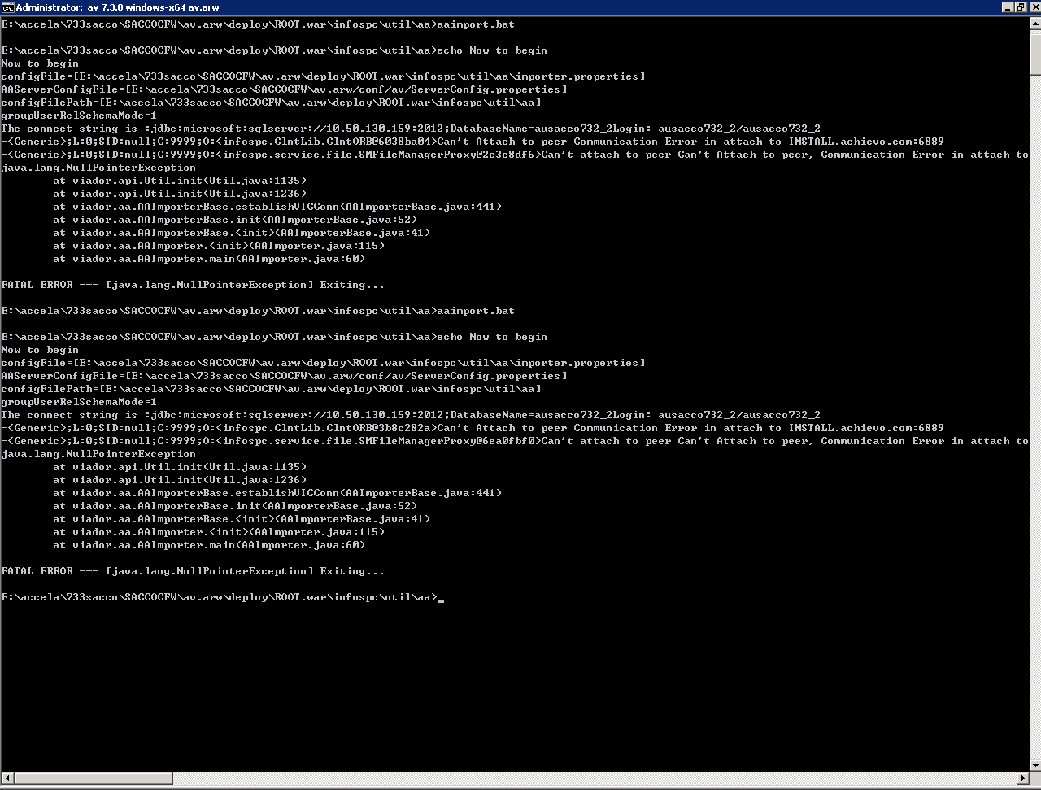

这个情况是我前面环境没配。

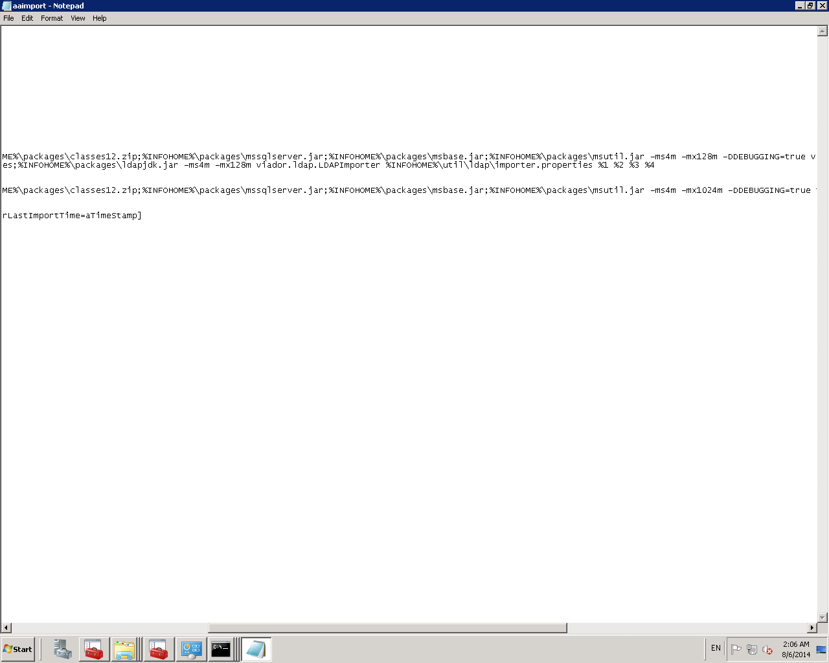

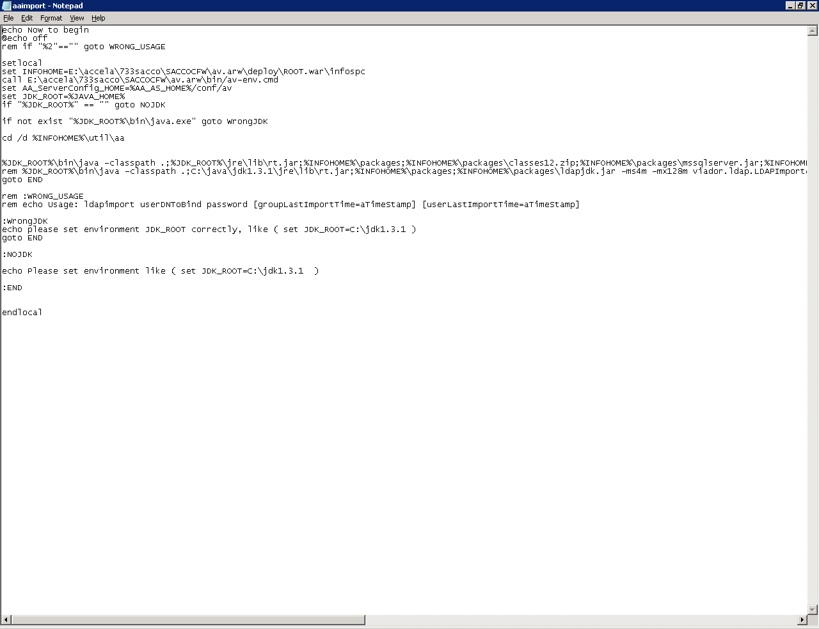

再次配置Vic时出现如下现象。

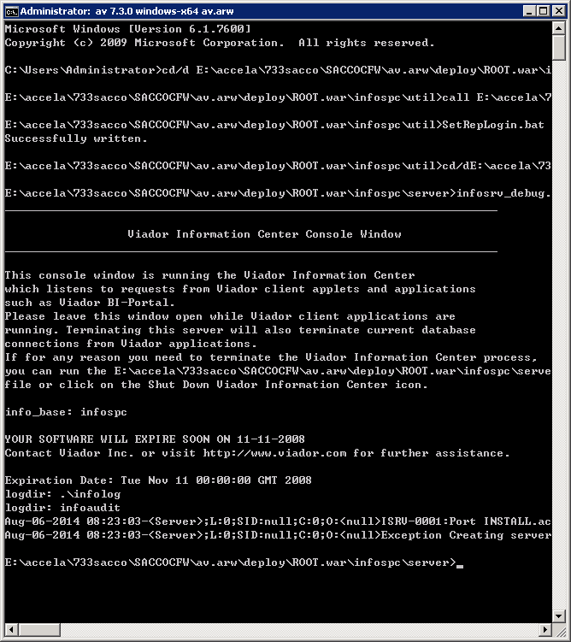

找到infosrvshutup.bat

Microsoft Windows [Version 6.3.9600]

(c) 2013 Microsoft Corporation. All rights reserved.

C:\Users\Administrator>cd/d C:\AccelaARW\PRODARW\av.arw\deploy\ROOT.war\infospc\

util

C:\AccelaARW\PRODARW\av.arw\deploy\ROOT.war\infospc\util>call C:\AccelaARW\PRODA

RW\av.arw\bin\av-env.cmd

C:\AccelaARW\PRODARW\av.arw\deploy\ROOT.war\infospc\util>SetRepLogin.bat arw arw

dbs39

Successfully written.

C:\AccelaARW\PRODARW\av.arw\deploy\ROOT.war\infospc\util>cd/d C:\AccelaARW\PRODA

RW\av.arw\deploy\ROOT.war\infospc\server

C:\AccelaARW\PRODARW\av.arw\deploy\ROOT.war\infospc\server>infosrv_debug.bat

________________________________________________________________________

Viador Information Center Console Window

________________________________________________________________________

This console window is running the Viador Information Center

which listens to requests from Viador client applets and applications

such as Viador BI-Portal.

Please leave this window open while Viador client applications are

running. Terminating this server will also terminate current database

connections from Viador applications.

If for any reason you need to terminate the Viador Information Center process,

you can run the C:\AccelaARW\PRODARW\av.arw\deploy\ROOT.war\infospc\server\infos

hutdown.bat

file or click on the Shut Down Viador Information Center icon.

info_base: infospc

YOUR SOFTWARE WILL EXPIRE SOON ON 11-11-2008

Contact Viador Inc. or visit http://www.viador.com for further assistance.

Expiration Date: Tue Nov 11 00:00:00 GMT 2008

logdir: .\infolog

logdir: infoaudit

initWorker : 2

maxWorker : 16

sleepTime : 1

TraceLevel : 0

txSupport : true

maxSqlCnt : 10

asyncOpt : false

dbRowDel : ;

dbColDel : ~|

sqlReqDel : ↔

connReTryCnt : 5

connReTryTime : 30

reconnect : true

Error: ORACLE Error: ORA-12154: TNS:could not resolve the connect ident

Error: Connection Fail.

GRSqlWkr 0 failed to login to Oracle as arw

will try again after 30 sec

Error: ORACLE Error: ORA-12154: TNS:could not resolve the connect ident

Error: Connection Fail.

GRSqlWkr 0 failed to login to Oracle as arw

will try again after 30 sec

Error: ORACLE Error: ORA-12154: TNS:could not resolve the connect ident

Error: Connection Fail.

GRSqlWkr 0 failed to login to Oracle as arw

will try again after 30 sec

Error: ORACLE Error: ORA-12154: TNS:could not resolve the connect ident

Error: Connection Fail.

GRSqlWkr 0 failed to login to Oracle as arw

will try again after 30 sec

Error: ORACLE Error: ORA-12154: TNS:could not resolve the connect ident

Error: Connection Fail.

GRSqlWkr 0 failed to login to Oracle as arw

will try again after 30 sec

GRSqlWkr 0 failed to login to Oracle as arw

GRSqlWkr 0 connected to DB failed!

GRSqlSrv V2.0.8 initialization failed!

TraceWkrT: STDERR -1: >

GRSqlSrv main is terminating!

TraceWkrT: StreamMonitor is terminating....

Nov-20-2014 11:03:45-<Server>;L:0;SID:null;C:0;O:<null>Unable to start service G

RSqlSrv. Exiting!

C:\AccelaARW\PRODARW\av.arw\deploy\ROOT.war\infospc\server>infosrv_debug.bat

________________________________________________________________________

Viador Information Center Console Window

________________________________________________________________________

This console window is running the Viador Information Center

which listens to requests from Viador client applets and applications

such as Viador BI-Portal.

Please leave this window open while c are

running. Terminating this server will also terminate current database

connections from Viador applications.

If for any reason you need to terminate the Viador Information Center process,

you can run the C:\AccelaARW\PRODARW\av.arw\deploy\ROOT.war\infospc\server\infos

hutdown.bat

file or click on the Shut Down Viador Information Center icon.

info_base: infospc

YOUR SOFTWARE WILL EXPIRE SOON ON 11-11-2008

Contact Viador Inc. or visit http://www.viador.com for further assistance.

Expiration Date: Tue Nov 11 00:00:00 GMT 2008

logdir: .\infolog

logdir: infoaudit

initWorker : 2

maxWorker : 16

sleepTime : 1

TraceLevel : 0

txSupport : true

maxSqlCnt : 10

asyncOpt : false

dbRowDel : ;

dbColDel : ~|

sqlReqDel : ↔

connReTryCnt : 5

connReTryTime : 30

reconnect : true

Error: ORACLE Error: ORA-12154: TNS:could not resolve the connect ident

Error: Connection Fail.

GRSqlWkr 0 failed to login to Oracle as arw

will try again after 30 sec

Error: ORACLE Error: ORA-12154: TNS:could not resolve the connect ident

Error: Connection Fail.

GRSqlWkr 0 failed to login to Oracle as arw

will try again after 30 sec

Error: ORACLE Error: ORA-12154: TNS:could not resolve the connect ident

Error: Connection Fail.

GRSqlWkr 0 failed to login to Oracle as arw

will try again after 30 sec

Error: ORACLE Error: ORA-12154: TNS:could not resolve the connect ident

Error: Connection Fail.

GRSqlWkr 0 failed to login to Oracle as arw

will try again after 30 sec

Error: ORACLE Error: ORA-12154: TNS:could not resolve the connect ident

Error: Connection Fail.

GRSqlWkr 0 failed to login to Oracle as arw

will try again after 30 sec

GRSqlWkr 0 failed to login to Oracle as arw

GRSqlWkr 0 connected to DB failed!

GRSqlSrv V2.0.8 initialization failed!

TraceWkrT: STDERR -1: >

GRSqlSrv main is terminating!

TraceWkrT: StreamMonitor is terminating....

Nov-20-2014 11:16:02-<Server>;L:0;SID:null;C:0;O:<null>Unable to start service G

RSqlSrv. Exiting!

C:\AccelaARW\PRODARW\av.arw\deploy\ROOT.war\infospc\server>

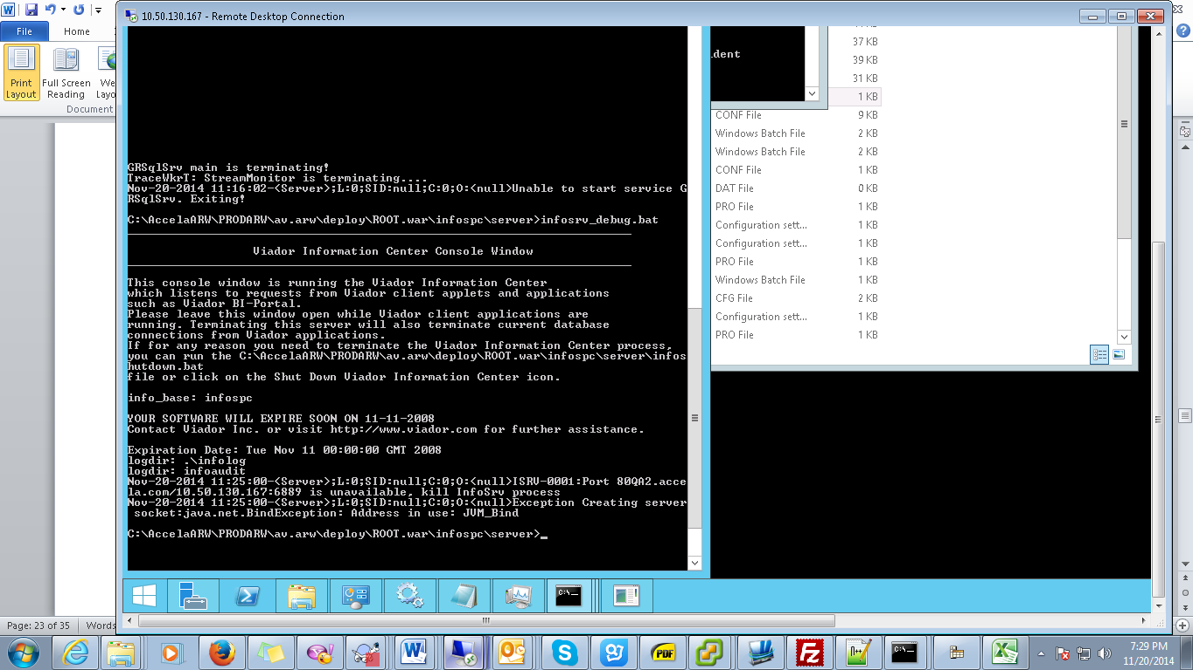

然后我用netstat –ano找到10.50.130.167:6889去关掉了

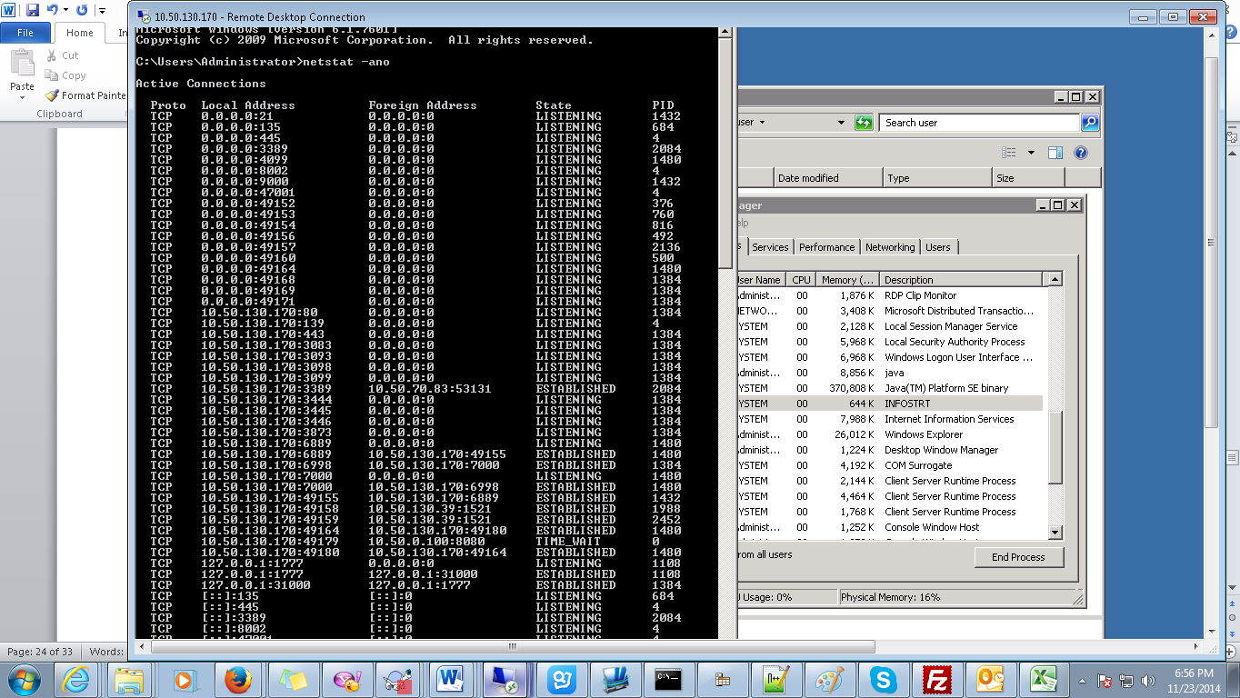

关掉6889

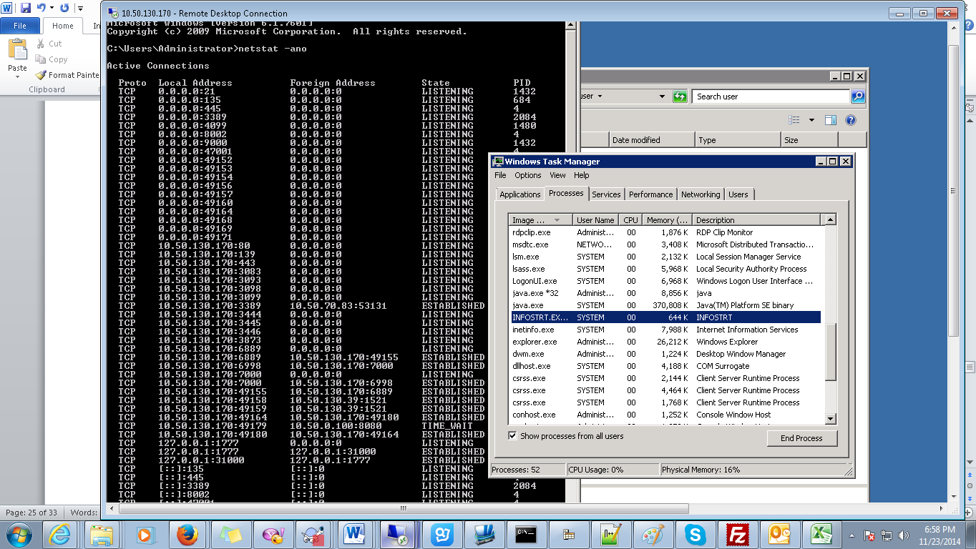

还把java.exe.32关了。Modify的时候发现80,3端口被占用了，然后去停掉对应1380 1400 2100，然后配置才终于成功跑起来。别忘了Oracleclient 要配置jdk环境变量。

看端口3时，也要查看四位，第四位是3就要小心了。





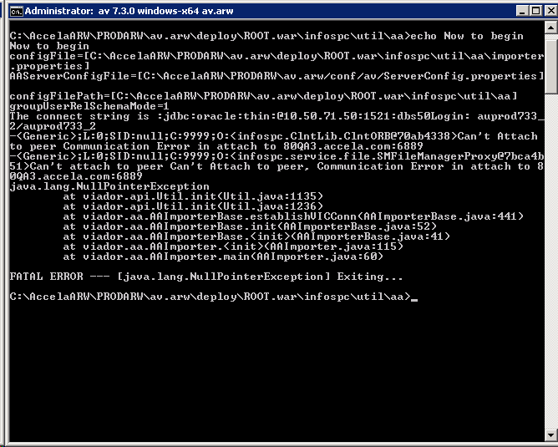



C:\AccelaARW\PRODARW\av.arw\deploy\ROOT.war\infospc\util\aa>echo Now to begin

Now to begin

configFile=[C:\AccelaARW\PRODARW\av.arw\deploy\ROOT.war\infospc\util\aa\importer

.properties]

AAServerConfigFile=[C:\AccelaARW\PRODARW\av.arw/conf/av/ServerConfig.properties]

configFilePath=[C:\AccelaARW\PRODARW\av.arw\deploy\ROOT.war\infospc\util\aa]

groupUserRelSchemaMode=1

The connect string is :jdbc:oracle:thin:@10.50.71.50:1521:dbs50Login: auprod733_

2/auprod733_2

-<Generic>;L:0;SID:null;C:9999;O:<infospc.ClntLib.ClntORB@70ab4338>Can't Attach

to peer Communication Error in attach to 80QA3.accela.com:6889

-<Generic>;L:0;SID:null;C:9999;O:<infospc.service.file.SMFileManagerProxy@7bca4b

51>Can't attach to peer Can't Attach to peer, Communication Error in attach to 8

0QA3.accela.com:6889

java.lang.NullPointerException

at viador.api.Util.init(Util.java:1135)

at viador.api.Util.init(Util.java:1236)

at viador.aa.AAImporterBase.establishVICConn(AAImporterBase.java:441)

at viador.aa.AAImporterBase.init(AAImporterBase.java:52)

at viador.aa.AAImporterBase.<init>(AAImporterBase.java:41)

at viador.aa.AAImporter.<init>(AAImporter.java:115)

at viador.aa.AAImporter.main(AAImporter.java:60)

FATAL ERROR --- [java.lang.NullPointerException] Exiting...

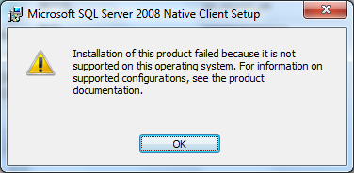

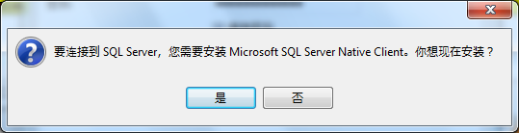

SVN出现下面的认证错：

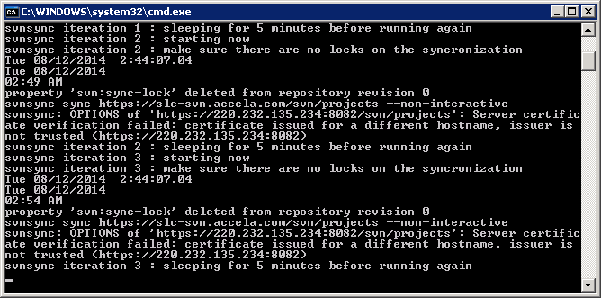

解决如下：<http://blog.chinaunix.net/uid-20718335-id-3077239.html>

截取了步骤，如下：

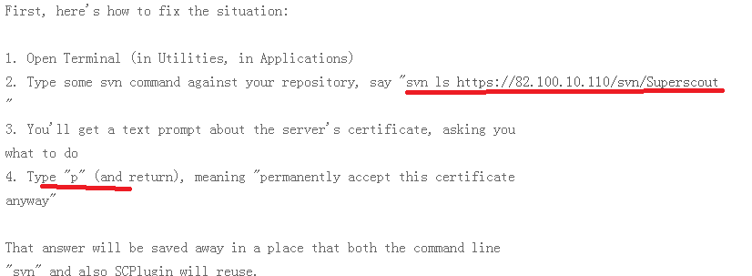

打开命令行，输入svn ls <https://220.232.135.234:8082/svn/projects> 回车

会让我们选择，输入： p

后面会要求输入username和password，填入就可以。（貌似我没输完，就zhi输入P，然后也可以解决问题，svnsync.projects.bat继续同步版本库，神奇）。

P@ss1j0y1

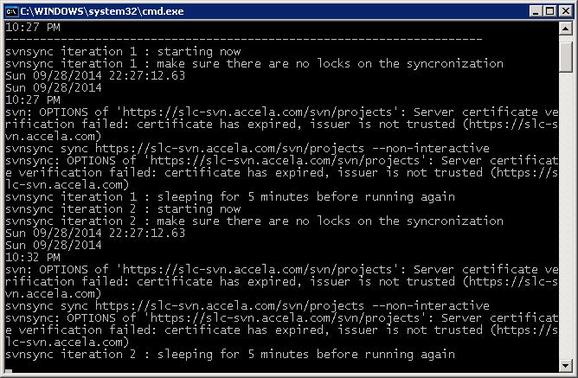

解决如下：

C:\Documents and Settings\jchen>svn ls https://slc-svn.accela.com/svn/projects

Error validating server certificate for 'https://slc-svn.accela.com:443':

- The certificate is not issued by a trusted authority. Use the

fingerprint to validate the certificate manually!

- The certificate has expired.

Certificate information:

- Hostname: slc-svn.accela.com

- Valid: from Fri, 27 Jun 2008 04:54:01 GMT until Mon, 27 Jun 2011 04:54:01 GMT

- Issuer: Engineering, Accela, Inc., Sandy, Utah, US

- Fingerprint: 25:48:17:48:fe:07:74:21:d0:c8:76:09:48:ba:69:39:f5:f9:bc:1f

(R)eject, accept (t)emporarily or accept (p)ermanently? p

Authentication realm: <https://slc-svn.accela.com:443> Subversion Repository

Password for 'jchen': *********

Authentication realm: <https://slc-svn.accela.com:443> Subversion Repository

Username: svnsync.accela

Password for 'svnsync.accela': ********

AMO/

AUTOTEST/

Aruba/

PerformanceTest/

SCM&Tools/

USSalesApp/

aad/

aca/

ads/

agis/

aivr/

amca/

amobile/

av/

aw/

govxml/

kiva/

pplus/

prototype/

tm/

vch/

C:\Documents and Settings\jchen>

然后就可以同步了。

svn: OPTIONS of 'https://slc-svn.accela.com/svn/projects': Server certificate verification failed: certificate has expired, issuer is not trusted (https://slc-svn.accela.com)

svnsync sync https://slc-svn.accela.com/svn/projects --non-interactive

svnsync: OPTIONS of 'https://slc-svn.accela.com/svn/projects': Server certificate verification failed: certificate has expired, issuer is not trusted (https://slc-svn.accela.com)

svnsync iteration 24 : sleeping for 5 minutes before running again

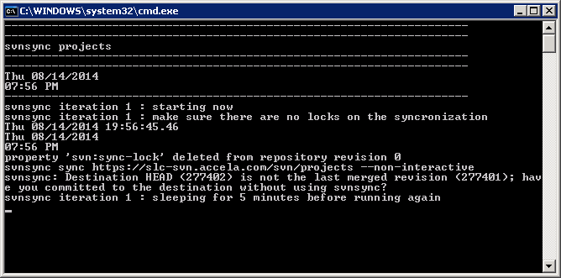

---------------------------------------------------------------------

---------------------------------------------------------------------

svnsync projects

---------------------------------------------------------------------

---------------------------------------------------------------------

Thu 08/14/2014

08:11 PM

---------------------------------------------------------------------

svnsync iteration 1 : starting now

svnsync iteration 1 : make sure there are no locks on the syncronization

Thu 08/14/2014 20:11:19.21

Thu 08/14/2014

08:11 PM

property 'svn:sync-lock' deleted from repository revision 0

svnsync sync https://slc-svn.accela.com/svn/projects --non-interactive

svnsync: Destination HEAD (277402) is not the last merged revision (277401); hav

e you committed to the destination without using svnsync?

svnsync iteration 1 : sleeping for 5 minutes before running again

找到一个相关的链接：<http://www.myexception.cn/cvs-svn/1076911.html>

property 'svn:sync-lock' deleted from repository revision 0

svnsync sync https://slc-svn.accela.com/svn/projects --non-interactive

svnsync: '/svn/projects/AUTOTEST/Tool/SeleniumFramework/Configuration/ProductCus

tomize/AA/ButtonConfiguration.xls' path not found

svnsync: ' .xls' path not found

